**Axis Direct Ring Technical Pre-Requisites**

|  |  |
| --- | --- |
| **OS** | Windows 10 |
| **Hard Disk Free Space Required** | 50 GB |
| **Dot.Net Framework** | 4.6.2 |
| **RAM** | 4 GB for Client |
| **Processor** | Intel® Core i3 & Above |
| **Internet** | 2Mbps & Above |

**Axis Direct Ring Setup Steps:**

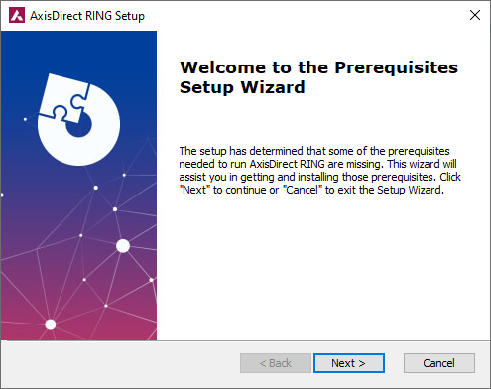

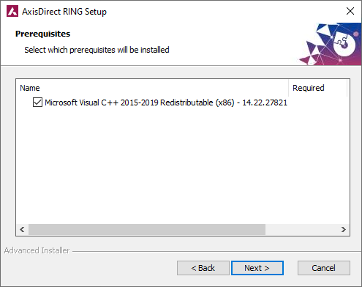

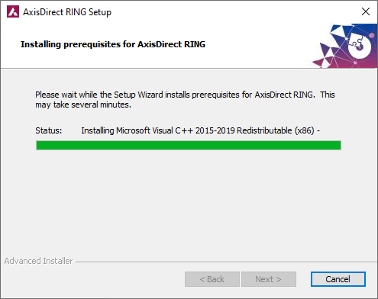

User need to download Dot Net Framework

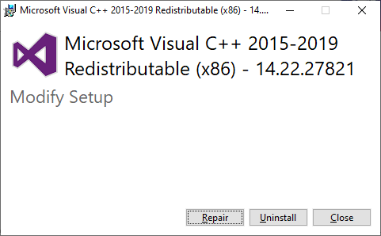

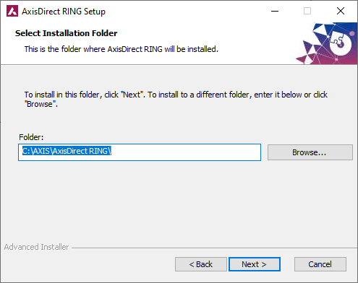

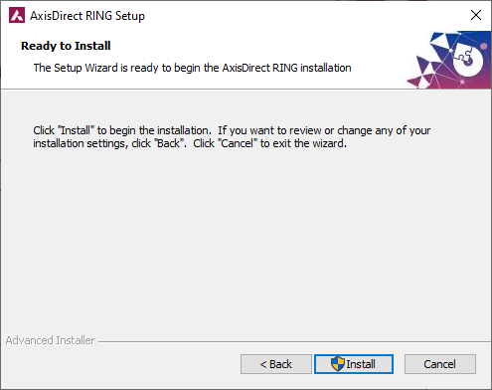

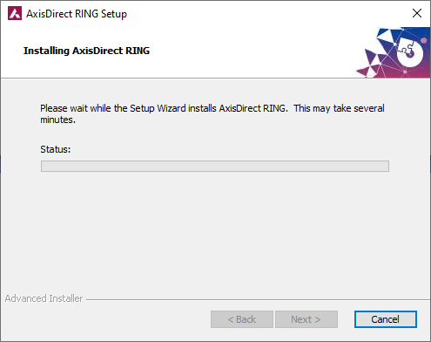

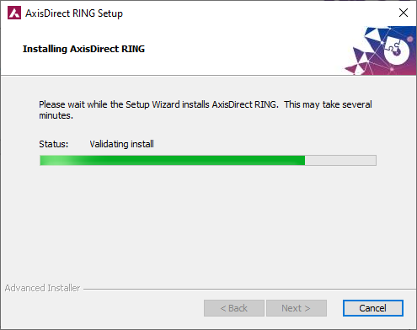

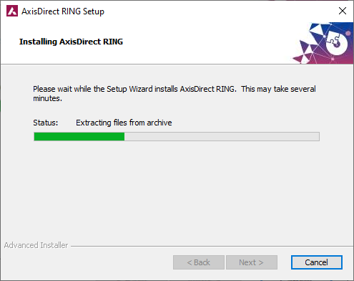

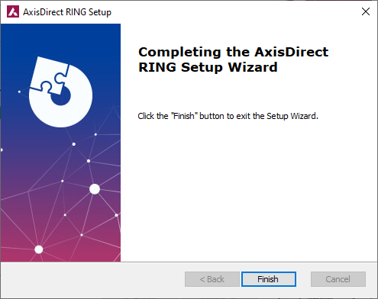

User need to click on finish to setup exe.

